Insurance Management System

0. Pre-Illumination
In Section 1 we gave problem description copied from Web site; in Section 2 we answered 3 questions listed in the project and justified our solution; in Section 3 we exhibited EER diagram with all assumptions; in Section 4 we showed our relational schema after normalization; in Section 5 we gave all requested SQL statements for both views and queries; and in Section 6 we gave dependency diagram induced from relational schemas. Finally, a short summary is given at the end of this report.

1. Problem Description
Design, develop, and test Insurance Management System that provides insurance services to clients, insurance companies and agents based on combined database. The project is in four parts: conceptual database design (Phase I), logical database design (Phase II), Oracle relational database implementation (Phase III), and final report &demo (Phase IV).
1) A client can get insurance quotes and file claims more than once. Each client contains such information: Client ID, Name, Age, Address, Phone Number (one or more phone numbers), and Email.
2) The system only provides two ways to clients getting quotes on their insurance, online with insurance companies and non-online with agents. Each quote, which has the attributes Quote ID, Date Prepared, Proposed Policy Period, and Premium, is issued by one particular client. Some quotes have discount that is uniquely determined by Discount Name and quote, whereas others do not. One quote may have one or more discounts which contain Discount Name and Rate.
3) Some clients in the system may file claims including Claim ID, Related Person (one or more), and Date. Each claim must associate with exact one policy. Adjusters who work for insurance companies evaluate the filed claims, and then process final reports respectively with the attributes Report Number, Report Date and Description. Report Number, Report Date and the claim determine one unique report. The same claim may be evaluated by different adjusters. Some reports may have refund that is an aggregation of Refund-Date, Amount, and Name of Related Person. Each refund is uniquely decided by specific report and Refund-Date. The system keeps tracking of accountants who issue refunds.
4) An agency has Name, Years in Business, and Tax ID information and must own one or more stores. The value of Tax ID is between “000001”
and “500000”. Each store belongs to one specific agency. It has the following information: Store Number, Name, Location (street, city, state, zip code), Phone Number and Level (1-5). The same store number may associate with different agencies, but Store Number with related agency determines one unique store. Agent# is a unique ID of agents, who work in stores and one or two of whom are managers of that store. Each agency sells insurance products provided by one or more insurance companies, but the number of related insurance companies cannot exceed 10. Some insurance companies may not have any agency.
5) An insurance company offers three types (auto, life, and home) of insurance products, and has the following information: Name, ISP, Website Address, Email and Phone Number. Each product contains Commission Rate, Code, Coverage, Limits/Deductibles and Premium; whereas Code, Coverage, Limits/Deductibles and the insurance company associated uniquely determine one specific product. The same product form one insurance company may have different commission rates to different agencies. Employees are hired by insurance companies with the following information: SSN, Name (Fname, Minit, and Lname), Age (<=65), Address (one or more), Phone Number, and Salary. All employees can be divided into three parts: Accountant, Actuary, and Adjuster. They may play more than one role at the same time. For adjusters, the system also records the rank.
6) Once a client accepts a quote, she/he would become a policy holder who holds a policy based on the accepted quote. One policy holder may have at most five insured persons who only have Name (may not be unique) recorded in the system. Meanwhile, each policy has a unique#, Date, Final Premium and Policy Terms. One policy must have one or more payments. For each payment, Serial Number (may not be unique), Date, and Amount are recorded, whereas Serial Number, Payment Date, and the policy determine one particular payment.

2. Three Questions
2.1 Can you think of 5 more rules (other than the one explicitly described above) that are likely to be used in a practical environment? Add your rules to the above requirement to be implemented.

5 more rules that can be likely to be ued in the system.

1. Clients who have more than 3 insurance are considered as the Prioroty customers.
2. Client Ailment information can be maintained in database.
3. Client can not have more than one claim for the same ailment.
4. Employees can not work as adjuster/accountant claims which belong to themselves or their dependent/s.
5. Employee’s manager’s approval is needed in case belongs to any of his/her employee or their dependent/s to avoid conflict of interest.
6. Policy can not have more than 10 payments.

2.2 Is the ability to model super-class/subclass relationships likely to be important in such environment? Why or why not?

Yes. We have used specialization for Employee, Client and Quote as below.
We adopted option which works for any specialization (total or partial, disjoint or overlapping).
Since all employees can be divided into three parts: Accountant, Actuary, and Adjuster, we have made them as subclasses of Employee and have used the overlapping constraint as they may play more than one role at the same time.
We created separate relations for Accountant, Actuary, and Adjuster.
Since some clients may accept the quote and then become Policy holder so we have made Policy Holder as sub class of the Client and have used subset notation to show this in the EER diagram.
Also We created separate relation for Policy Holder.
Since clients gets quotes on their insurance, online with insurance companies and non-online(Offline) with agents, we have divided QUOTE into two subclasses ONLINE_QUOTE and OFFLINE_QUOTE. And since system provides only 2 ways of getting the quote, we have used the disjoint constraint as quote can be either online or offline.
We created separate relations for ONLINE_QUOTE and OFFLINE_QUOTE.

2.3 Justify using a Relational DBMS like Oracle for this project.
We are using ORACLE because of all the benefits we get form the complete package and its usefulness with respect to our system. Here is the list of some of the good point related to ORACLE and the facilities provided by such RDBMS:-
1) Semantic Data Management Characteristics:-
• Discovery of data relationships across.
• Structured data (database, apps, web services)
• Unstructured data (email, office documents) Multi-data types (graphs, spatial, text, sensors)
• Text Mining & Web Mining infrastructure
• Terabytes of structured & unstructured data
• Queries are not defined in advance
• Schemas are continuously evolving
• Overcome isolated systems design
• Built on open, industry standards:
2) Why is this Useful?
• Designed to represent knowledge in a distributed world
• A method to decompose knowledge into small pieces, with rules about the semantics of those pieces
• Allows you to model and integrate DBMS schemas
• Allows you to integrate data from different sources without custom programming
• Supports decentralized data management
• Infer implicit relationships across data
One of the main advantage of oracle over other databases is in its recent version oracle has the concept of Flashback technology. That is we all know that data is the heart of any application or organization and thus this requires careful maintenance. But sometimes application outage can occur and mostly DBA claim the reasons for this as hardware failure and apart from this the reason would be human errors like accidental deletion of valuable data, deleting the wrong data, or dropping the wrong table. So it is very essential to take care of such situation and this is done in oracle's latest technology called flash introduced in its latest version. By Flash technology it helps in recovery by working just on the changed data. Thus Flashback provides an
• Efficient recovery from human errors
• Faster database recovery
• Helps in simplifying the management and administration processes

3. EER diagram with all assumptions
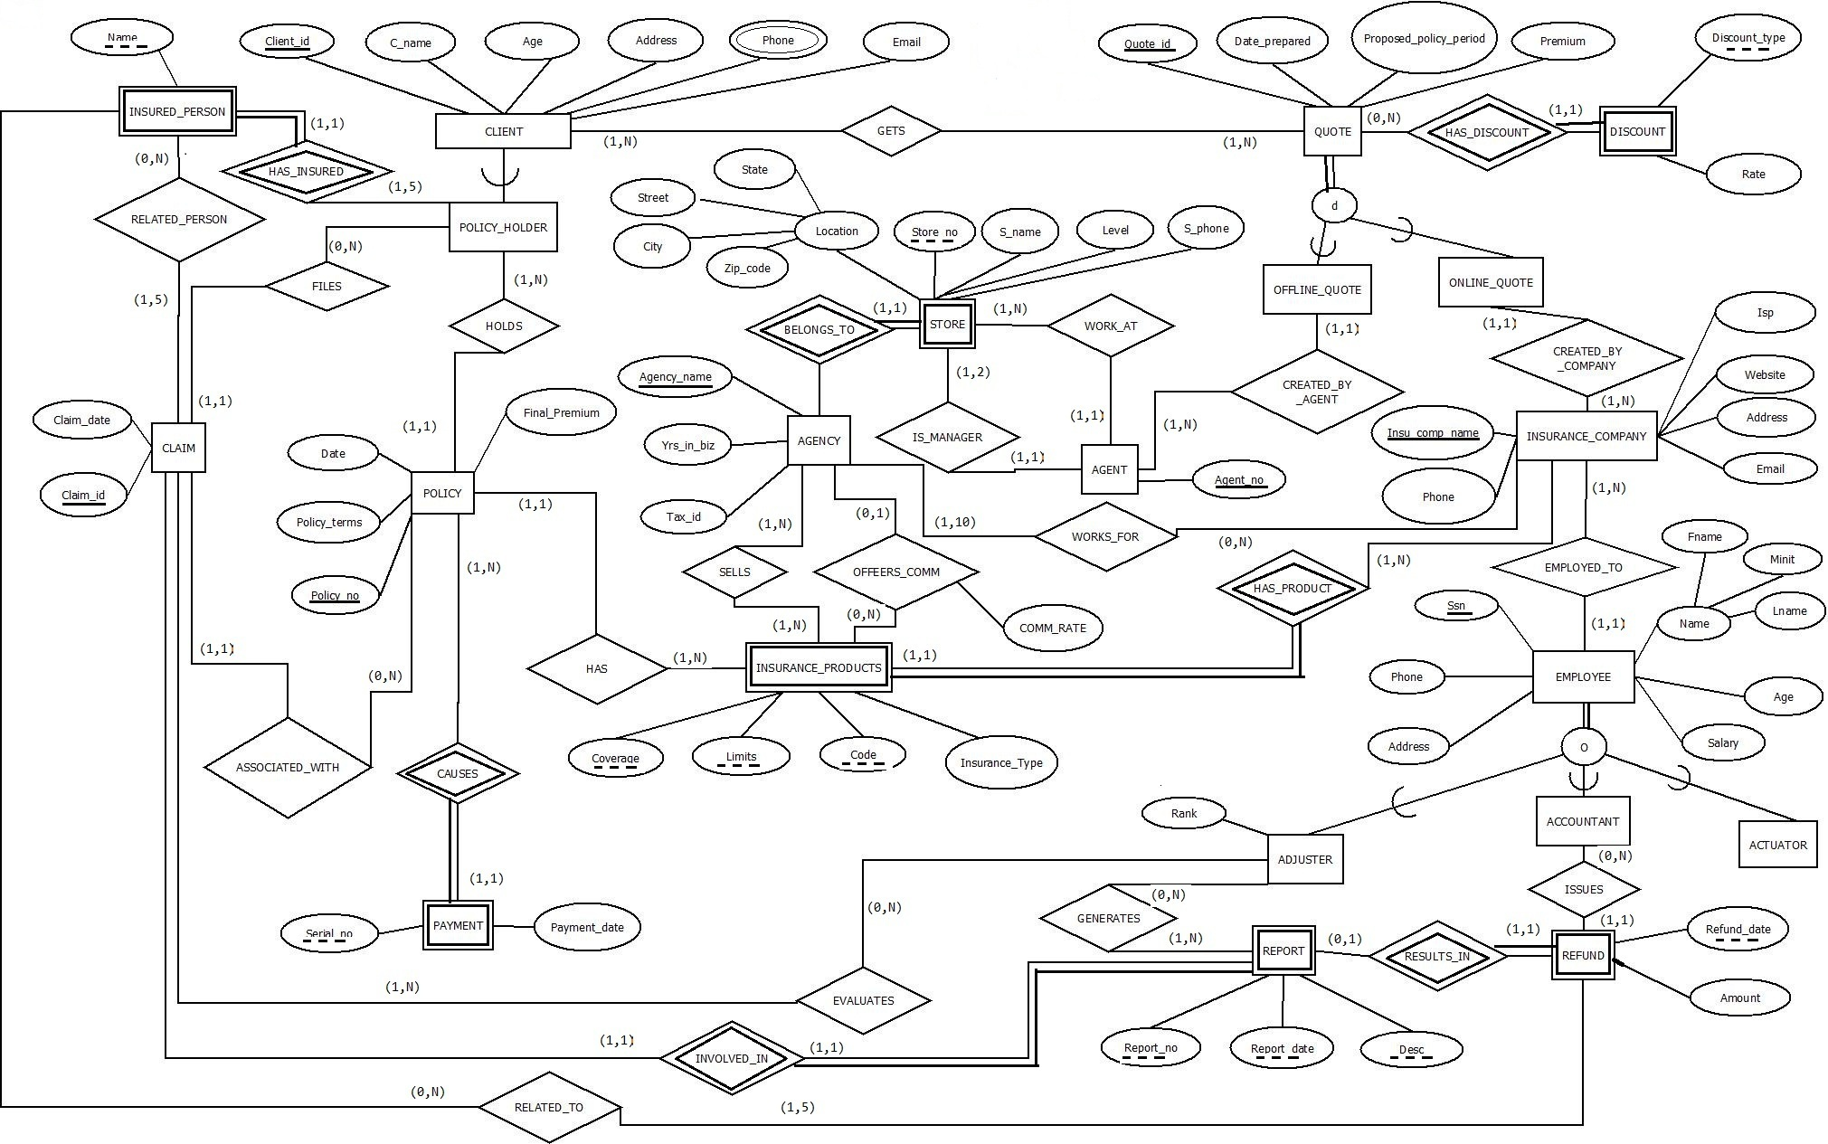
4. Relational Schema in Third Normal Form
4.1 Relational Schema
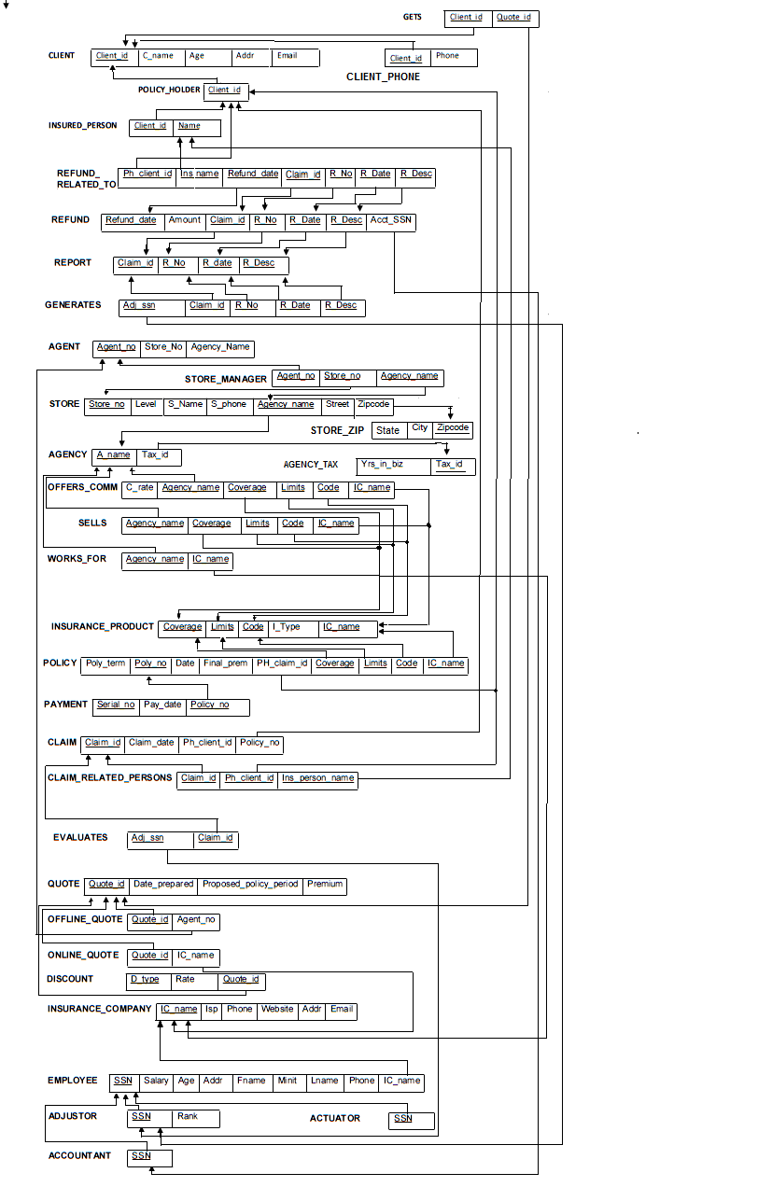

As per the below Assumptions we made the changes in Relational schema such that it satisfies the 3NF form.

In order to normalise our database in 3rd normal form we had to make few minor changes in design, these are listed below
1. We created new table for STORE_ZIP out of STORE since city and state are dependant on Zip and rest of the attributes were dependant on Store_no & Agency_name. So this was violeting the 3rd normal form as there were 2 functional dependencies in one table so we broke and created new table STORE_ZIP with its new attributes as Zip,City and State.
2. Similaraly we faced same issue for the table AGENCY where there were multiple functional dependencies were found and to normalize it we separated the table in AGENCY & AGENCY_TAX.
These canes are reflected in the above relatonal diagram.

4.2 Format for Every Relation
Relation Name | Attributes | Data type
CLIENT | Client_id | AXXXXX string = 6 chars where A is first characters of name & rest are digits.
 | C_name | string <= 20 chars
 | Age | Integer
 | Addr | string <= 40 chars
 | Email | string <= 20 chars
 | Phone | XXX-XXX-XXXX, string = 12 chars
CLIENT_PHONE | Email | string <= 20 chars
 | Client_id | AXXXXX string = 6 chars where A is first characters of name & rest are digits.
POLICY_HOLDER | Client_id | AXXXXX string = 6 chars where A is first characters of name & rest are digits.
INSURED_PERSON | Name | string = 12 chars
 | Client_id | AXXXXX string = 6 chars where A is first characters of name & rest are digits.
QUOTE | Quote_id | Q-XXXXX string of 7 chars with last 5 chars as digits
 | Date_prepared | MM/DD/YYYY, string = 10 chars
 | Proposed_policy_period | integer # of years
 | Premium | Float
OFFLINE_QUOTE | Quote_id | Q-XXXXX string of 7 chars with last 5 chars as digits
 | Agent_no | Integer
ONLINE_QUOTE | Quote_id | Q-XXXXX string of 7 chars with last 5 chars as digits
 | Ic_name | string <= 20 chars
DISCOUNT | Rate | Float
 | D_type | string <= 20 chars
 | Quote_id | Q-XXXXX string of 7 chars with last 5 chars as digits
AGENT | Agent_no | Integer
 | Store_no | Integer
 | Agency_name | string <= 20 chars
AGENCY | A_name | string <= 20 chars
 | Yrs_in_biz | Integer
 | Tax_id | string <= 10 chars
AGENCY_TAX | Yrs_in_biz | Integer
 | Tax_id | string <= 10 chars
STORE | Store_no | Integer
 | S_name | string <= 20 chars
 | Level | Integer (1-5)
 | S_phone | XXX-XXX-XXXX, string = 12 chars
 | Street | Integer
 | Zip_code | XXXXX Integer (5 digits)
 | A_name | string <= 20 chars
STORE_ZIP | City | string <= 20 chars
 | State | string <= 20 chars
 | Zip_code | XXXXX Integer (5 digits)
INSURANCE_COMPANY | Ic_name | string <= 20 chars
 | Isp | string <= 20 chars
 | Website | string <= 40 chars
 | Address | string <= 40 chars
 | Email | string <= 20 chars
 | Phone | XXX-XXX-XXXX, string = 12 chars
INSURANCE_PRODUCTS | Coverage | string <= 40 chars
 | Limits | string <= 40 chars
 | Code | string <= 20 chars
 | Insurance_Type | (Auto, Life, Home)
 | Ic_name | string <= 20 chars
EMPLOYEE | Ssn | XXX-XX-XXXX, string = 11 chars, where X is any digit
 | Phone | XXX-XXX-XXXX, string = 12 chars
 | Fname | string <= 20 chars
 | Minit | string <= 20 chars
 | Lname | string <= 20 chars
 | Salary | Float
 | Age | Integer
 | Address | string <= 40 chars
 | Ic_name | string <= 20 chars
ACCOUNTANT | Ssn | XXX-XX-XXXX, string = 11 chars, where X is any digit
ADJUSTER | Ssn | XXX-XX-XXXX, string = 11 chars, where X is any digit
 | Rank | Integer (1-5)
ACTUARY | Ssn | XXX-XX-XXXX, string = 11 chars, where X is any digit
CLAIM | Claim_id | C-XXXXXXXXXX String of 12 chars where X = digit
 | Claim_date | MM/DD/YYYY, string = 10 chars
 | Ph_client_id | AXXXXX string = 6 chars where A is first characters of name & rest are digits.
 | Policy_no | Integer
REPORT | R_no | Integer
 | Report_date | MM/DD/YYYY, string = 10 chars
 | R_desc | string <= 40 chars
 | Claim_id | C-XXXXXXXXXX String of 12 chars where X = digit
REFUND | Refund_date | MM/DD/YYYY, string = 10 chars
 | Amount | Float
 | Report_date | MM/DD/YYYY, string = 10 chars
 | R_desc | string <= 40 chars
 | Claim_id | C-XXXXXXXXXX String of 12 chars where X = digit
 | R_no | Integer
 | Acc_ssn | XXX-XX-XXXX, string = 11 chars, where X is any digit
PAYMENT | Serial_no | Integer
 | Payment_date | MM/DD/YYYY, string = 10 chars
 | Policy_no | Integer
POLICY | Policy_no | Integer
 | Date | MM/DD/YYYY, string = 10 chars
 | Final_Premium | Float
 | Policy_terms | string <= 40 chars
 | Phc_claim_id | C-XXXXXXXXXX String of 12 chars where X = digit
 | Coverage | string <= 40 chars
 | Limits | string <= 40 chars
 | Code | string <= 20 chars
 | Ic_name | string <= 20 chars
GETS | Client_id | AXXXXX string = 6 chars where A is first characters of name & rest are digits.
 | Quote_id | Q-XXXXX string of 7 chars with last 5 chars as digits
OFFERS_COM | c_rate | Float
 | A_name | string <= 20 chars
 | Coverage | string <= 40 chars
 | Limits | string <= 40 chars
 | Code | string <= 20 chars
 | Ic_name | string <= 20 chars
SELLS | A_name | string <= 20 chars
 | Coverage | string <= 40 chars
 | Limits | string <= 40 chars
 | Code | string <= 20 chars
 | Ic_name | string <= 20 chars
WORKS_FOR | A_name | string <= 20 chars
 | Ic_name | string <= 20 chars
EVALUATES | Claim_id | C-XXXXXXXXXX String of 12 chars where X = digit
 | Adj_ssn | XXX-XX-XXXX, string = 11 chars, where X is any digit
GENERATES | Claim_id | C-XXXXXXXXXX String of 12 chars where X = digit
 | Adj_ssn | XXX-XX-XXXX, string = 11 chars, where X is any digit
 | R_no | Integer
 | Report_date | MM/DD/YYYY, string = 10 chars
 | R_desc | string <= 40 chars
CLAIM_RELATED_PERSONS | Claim_id | C-XXXXXXXXXX String of 12 chars where X = digit
 | Phc_id | AXXXXX string = 6 chars where A is first characters of name & rest are digits.
 | Insured_person_name | string = 12 chars
REFUND_RELATED_TO | Claim_id | C-XXXXXXXXXX String of 12 chars where X = digit
 | Phc_id | AXXXXX string = 6 chars where A is first characters of name & rest are digits.
 | Insured_person_name | string = 12 chars
 | Refund_date | MM/DD/YYYY, string = 10 chars
 | Report_date | MM/DD/YYYY, string = 10 chars
 | R_desc | string <= 40 chars
 | R_no | Integer
STORE_MGR | A_name | string <= 20 chars
 | Store_no | Integer
 | Agent_no | Integer

5. All Requested SQL Statements
5.1 Creation of Database with SQL Statements
5.1.1 Table Creation
create table CLIENT
(
Client_id varchar(6),
C_name varchar(30),
Age number,
Addr varchar(40),
Email varchar(20),
constraint CLIENTPK primary key(Client_id)
);

create table CLIENT_PHONE
(
Client_id varchar(6),
Phone varchar(12),
constraint CLIENT_PHONEPK primary key(Client_id,Phone),
constraint CLIENT_PHONEFK foreign key(Client_id) references CLIENT(client_id)
);

create table POLICY_HOLDER
(
Client_id varchar(6),
constraint POLICY_HOLDERPK primary key(Client_id),
constraint POLICY_HOLDERFK foreign key(Client_id) references CLIENT(client_id)
);

create table INSURED_PERSON
(
name varchar(12),
Client_id varchar(6),
constraint INSURED_PERSONPK primary key(name,client_id),
constraint INSURED_PERSONFK foreign key(Client_id) references CLIENT(client_id)
);

create table QUOTE
(
Quote_id varchar(7),
Date_prepared date,
Proposed_policy_period number,
Premium number(10,2),
constraint QUOTEPK primary key(quote_id)
);

create table AGENCY_TAXID(
Tax_id varchar(10) ,
Yrs_in_biz number ,
constraint AGENCY_TAXIDPK1 primary key(Tax_id)
);

create table AGENCY(
A_name varchar(20) ,
Tax_id varchar(10) ,
constraint AGENCYPK1 primary key(A_name),
constraint AGENCYFK2 foreign key (Tax_id) references AGENCY_TAXID(Tax_id)
);

create table STORE_ZIP
(
City varchar(20),
State varchar(20),
Zip_code number(5,0),
constraint STORE_ZIPPK1 primary key(Zip_code)
);

create table STORE
(Store_no INT,
S_name varchar(20),
Level1 INT,
S_phone varchar(12) ,
Zip_code number(5,0),
A_name varchar(20),
Street number,
constraint STOREPK1 primary key(Store_no,A_name),
constraint STOREFK2 foreign key (A_name) references Agency(A_name),
constraint STOREFK3 foreign key (Zip_code) references STORE_ZIP(Zip_code),
CHECK ( Level1>0 and Level1<6)
);

create table AGENT(
Agent_no number ,
Store_no INT ,
Agency_name varchar(20) ,
constraint AGENTPK primary key(Agent_no),
constraint AGENTFK1 foreign key (store_no,Agency_name) references STORE(store_no,A_name),
constraint AGENTFK2 foreign key (Agency_name) references Agency(A_name)
);

create table INSURANCE_COMPANY (
Ic_name varchar(20) ,
Isp varchar(20) ,
Website varchar(40) ,
Address varchar(40) ,
Email varchar(20) ,
Phone varchar(12) ,
constraint INSURANCE_COMPANYPK primary key(Ic_name)
);

create table OFFLINE_QUOTE(
Quote_id varchar(7),
Agent_no INT ,
constraint OFFLINE_QUOTEPK primary key(quote_id),
constraint OFFLINE_QUOTEFK1 foreign key (Agent_no) references agent(agent_no),
constraint OFFLINE_QUOTEFK2 foreign key (quote_id) references QUOTE(quote_id)
);

create table ONLINE_QUOTE(
Quote_id varchar(7) ,
Ic_name varchar(20),
constraint QUOTEPK1 primary key(quote_id),
constraint ONLINE_QUOTEFK foreign key(Ic_name) references INSURANCE_COMPANY(Ic_name),
constraint OFFLINE_QUOTEFK foreign key (quote_id) references QUOTE(quote_id)
);

create table INSURANCE_PRODUCTS(
Coverage varchar(40) ,
Limits varchar(40) ,
Code varchar(20) ,
Insurance_Type varchar(10) ,
Ic_name varchar(20) ,
constraint INSURANCE_PRODUCTSPK primary key(Coverage,Limits,Code,Ic_name),
constraint INSURANCE_PRODUCTSFK foreign key(Ic_name) references INSURANCE_COMPANY(Ic_name)
);

create table DISCOUNT(
Rate float(8) ,
D_type varchar(20) ,
Quote_id varchar(7) ,
constraint DISCOUNTPK primary key(D_type,quote_id),
constraint DISCOUNTFK foreign key (quote_id) references QUOTE(quote_id)
);

create table EMPLOYEE(
Ssn varchar(11),
Phone varchar(12),
fname varchar(20),
Minit varchar(20),
Lname varchar(20),
Salary float(8),
Age INT,
Address varchar(40),
Ic_name varchar(20),
constraint EMPLOYEEPK primary key(Ssn),
constraint EMPLOYEEFK foreign key(Ic_name) references INSURANCE_COMPANY(Ic_name)
);

create table ACCOUNTANT(
Ssn varchar(11),
constraint ACCOUNTANTPK primary key(Ssn),
constraint ACCOUNTANTFK foreign key(Ssn) references EMPLOYEE(Ssn)
);

create table ADJUSTER(
Ssn varchar(11),
Rank INT,
constraint ADJUSTERPK primary key(Ssn),
constraint ADJUSTERFK foreign key(Ssn) references EMPLOYEE(Ssn),
CHECK (Rank>0 and Rank <6)
);

create table ACTUARY(
Ssn varchar(11),
constraint ACTUARYPK primary key(Ssn),
constraint ACTUARYFK foreign key(Ssn) references EMPLOYEE(Ssn)
);

CREATE TABLE POLICY
(Policy_no Int,
PDate date,
Final_Premium float(8),
Policy_terms VarChar(40),
Ph_client_id VarChar(12),
Coverage VarChar(40),
Limits VarChar(40),
Code VarChar(20),
Ic_name VarChar(20),
Constraint PolicyPk PRIMARY KEY(Policy_no),
CONSTRAINT Ph_client_idFk FOREIGN KEY(Ph_client_id) REFERENCES POLICY_HOLDER(Client_id),
CONSTRAINT CoverageFk FOREIGN KEY(Coverage,Limits,Code,Ic_name) REFERENCES INSURANCE_PRODUCTS(Coverage,Limits,Code,Ic_name));

CREATE TABLE CLAIM
(Claim_id VarChar(12),
Claim_date date,
Ph_client_id VarChar(6),
Policy_no Int,
Constraint ClaimPk PRIMARY KEY(Claim_id),
CONSTRAINT CLAIMFk1 FOREIGN KEY(Ph_client_id) REFERENCES POLICY_HOLDER(Client_id),
CONSTRAINT CLAIMFk2 FOREIGN KEY(Policy_no) REFERENCES POLICY(Policy_no));

CREATE TABLE PAYMENT
(Serial_no Int,
Payment_date date,
Policy_no Int,
Constraint PaymentPk PRIMARY KEY(Serial_no,Policy_no),
CONSTRAINT PAYMENTFk FOREIGN KEY(Policy_no) REFERENCES POLICY(Policy_no));

CREATE TABLE GETS
(Client_id VarChar(6),
Quote_id VarChar(7),
Constraint GetsPk PRIMARY KEY(Client_id,Quote_id),
CONSTRAINT GETSFk1 FOREIGN KEY(Client_id) REFERENCES CLIENT(Client_id),
CONSTRAINT GETSFk2 FOREIGN KEY(Quote_id) REFERENCES QUOTE(Quote_id));

CREATE TABLE REPORT
(R_no Int,
Report_date date,
R_desc VarChar(40),
Claim_id VarChar(12),
Constraint ReportPk PRIMARY KEY(R_no,Report_date,R_desc,Claim_id),
CONSTRAINT REPORTFk FOREIGN KEY(Claim_id) REFERENCES CLAIM(Claim_id));

CREATE TABLE WORKS_FOR
(A_name VarChar(20),
Ic_name VarChar(20),
Constraint WorksForPk PRIMARY KEY(A_name,Ic_name),
CONSTRAINT WORKSFORFk1 FOREIGN KEY(A_name) REFERENCES AGENCY(A_name),
CONSTRAINT WORKSFORFk2 FOREIGN KEY(Ic_name) REFERENCES INSURANCE_COMPANY(Ic_name));

CREATE TABLE EVALUATES
(Claim_id VarChar(12),
Adj_ssn VarChar(11),
Constraint EvaluatesPk PRIMARY KEY(Claim_id,Adj_ssn),
CONSTRAINT Claim_idFk FOREIGN KEY(Claim_id) REFERENCES CLAIM(Claim_id),
CONSTRAINT Adj_ssnFk FOREIGN KEY(Adj_ssn) REFERENCES ADJUSTER(ssn));

CREATE TABLE OFFERS_COM
(c_rate float(8),
A_name VarChar(20),
Coverage VarChar(40),
Limits VarChar(40),
Code VarChar(20),
Ic_name VarChar(20),
Constraint OffersComPk PRIMARY KEY(c_rate,A_name,Coverage,Limits,Code,Ic_name),
CONSTRAINT OFFERSCOMMFk1 FOREIGN KEY(A_name) REFERENCES AGENCY(A_name),
CONSTRAINT OFFERSCOMMFk2 FOREIGN KEY(Coverage,Limits,Code,Ic_name) REFERENCES INSURANCE_PRODUCTS(Coverage,Limits,Code,Ic_name));

CREATE TABLE SELLS
(A_name VarChar(20),
Coverage VarChar(40),
Limits VarChar(40),
Code VarChar(20),
Ic_name VarChar(20),
Constraint SellsPk PRIMARY KEY(A_name,Coverage,Limits,Code,Ic_name),
CONSTRAINT SELLSFk1 FOREIGN KEY(A_name) REFERENCES AGENCY(A_name),
CONSTRAINT SELLSFk2 FOREIGN KEY(Coverage,Limits,Code,Ic_name) REFERENCES INSURANCE_PRODUCTS(Coverage,Limits,Code,Ic_name));

CREATE TABLE REFUND
(Refund_date date,
Amount float(8),
Report_date date,
R_desc VarChar(40),
Claim_id VarChar(12),
R_no Int,
Acc_ssn VarChar(11),
Constraint RefundPk PRIMARY KEY(Refund_date,Report_date,R_desc,Claim_id,R_no),
CONSTRAINT REFUNDFk1 FOREIGN KEY(Claim_id,R_no,Report_date,R_desc) REFERENCES REPORT(Claim_id,R_no,Report_date,R_desc),
CONSTRAINT REFUNDFk2 FOREIGN KEY(Acc_ssn) REFERENCES ACCOUNTANT(Ssn));

CREATE TABLE GENERATES
(Claim_id VarChar(12),
Adj_ssn VarChar(11),
R_no Int,
Report_date date,
R_desc VarChar(40),
Constraint GeneratesPk PRIMARY KEY(Claim_id,Adj_ssn,R_no,Report_date,R_desc),
CONSTRAINT ADJUSTERFk1 FOREIGN KEY(Adj_ssn) REFERENCES ADJUSTER(ssn),
CONSTRAINT REPORTFk2 FOREIGN KEY(Claim_id,R_no,Report_date,R_desc) REFERENCES REPORT(Claim_id,R_no,Report_date,R_desc));

CREATE TABLE REFUND_RELATED_TO
(Claim_id VarChar(12),
Phc_id VarChar(6),
Insured_person_name VarChar(12),
Refund_date date,
Report_date date,
R_desc VarChar(40),
R_no Int,
Constraint RefundRelatedToPk PRIMARY KEY(Phc_id,Insured_person_name,Refund_date,Claim_id,R_no,Report_date,R_desc),
CONSTRAINT REFUND_RELATED_TOFk2 FOREIGN KEY(Insured_person_name,Phc_id) REFERENCES INSURED_PERSON(Name,CLIENT_ID),
CONSTRAINT REFUND_RELATED_TOFk3 FOREIGN KEY(Refund_date,Claim_id,R_no,Report_date,R_desc) REFERENCES REFUND(Refund_date,Claim_id,R_no,Report_date,R_desc));

CREATE TABLE CLAIM_RELATED_PERSONS
(Claim_id VarChar(12),
Phc_id VarChar(6),
Insured_person_name VarChar(12),
Constraint ClainRelatedPersonPk PRIMARY KEY(Claim_id,Phc_id,Insured_person_name),
CONSTRAINT CLAIM_RELATED_PERSONSFk1 FOREIGN KEY(Claim_id) REFERENCES CLAIM(Claim_id),
CONSTRAINT CLAIM_RELATED_PERSONSFk2 FOREIGN KEY(Insured_person_name,Phc_id) REFERENCES INSURED_PERSON(Name,Client_id));

CREATE TABLE STORE_MGR
(A_name VarChar(20) NOT NULL,
Store_no Int,
Agent_no Int,
CONSTRAINT StoreMgrPk PRIMARY KEY(A_name,Store_no,Agent_no),
CONSTRAINT STORE_MGRFk1 FOREIGN KEY(A_name,Store_no) REFERENCES STORE(A_name,Store_no),
CONSTRAINT STORE_MGRFk2 FOREIGN KEY(Agent_no) REFERENCES AGENT(Agent_no));

5.1.2 A Database State
We inserted some values into the database in order to test our SQL create view and query statement. Here are the snapshots that shows the data in the tables

Below are the screenshots of the Database state:

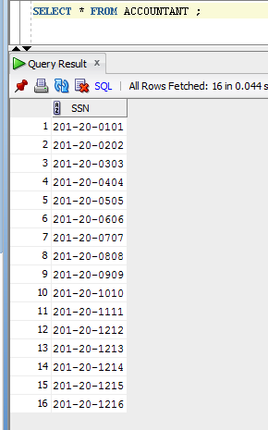

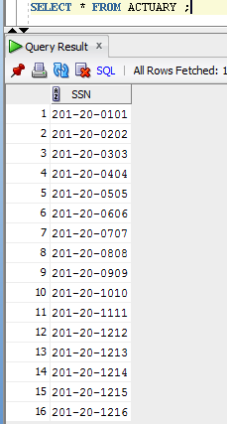

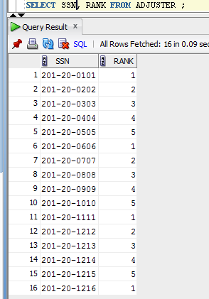

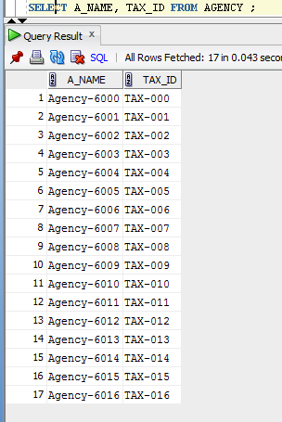

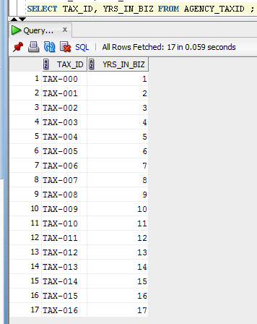

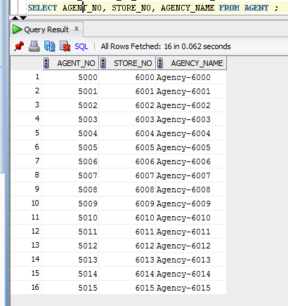

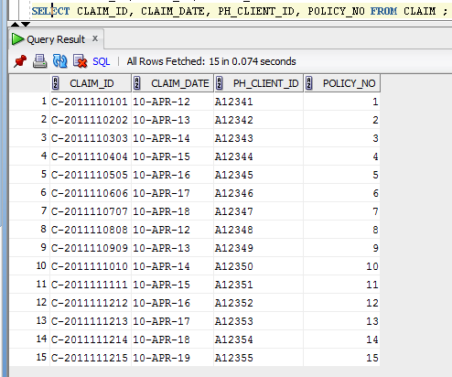

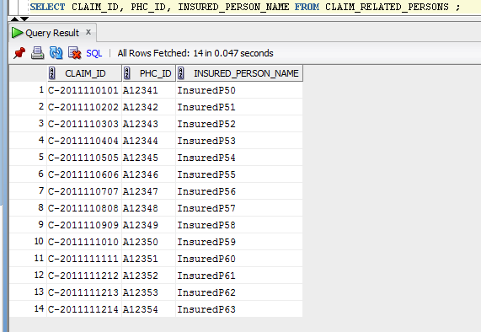
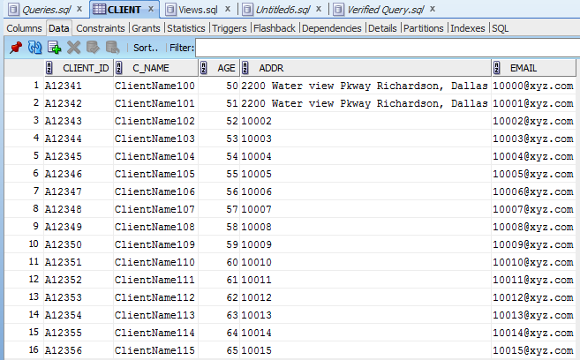

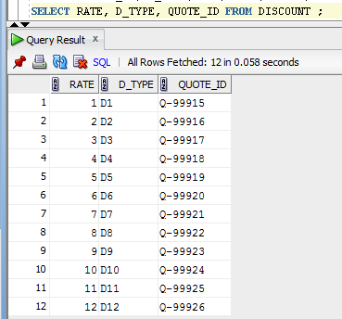

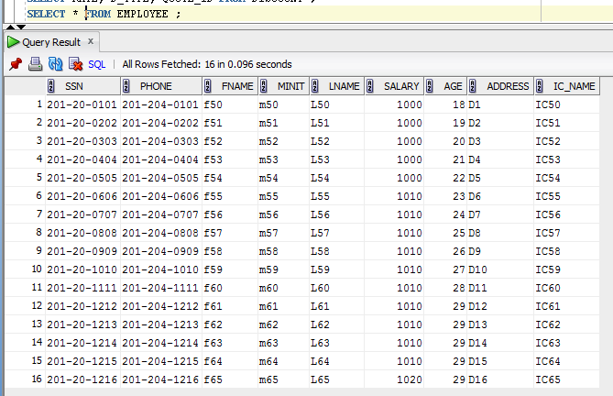

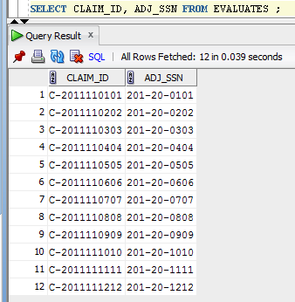

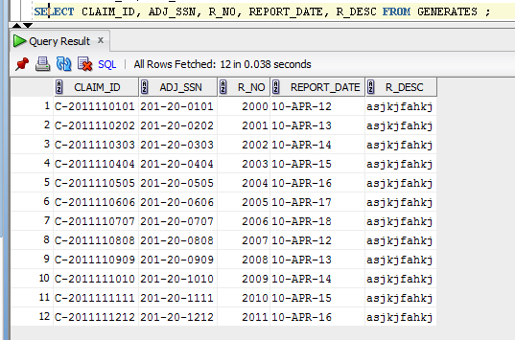

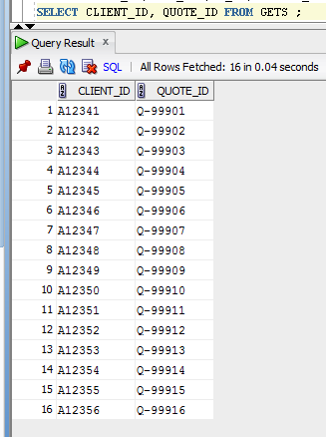

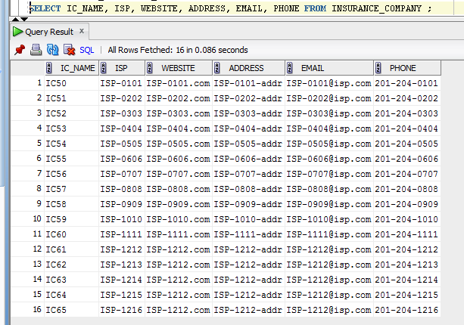

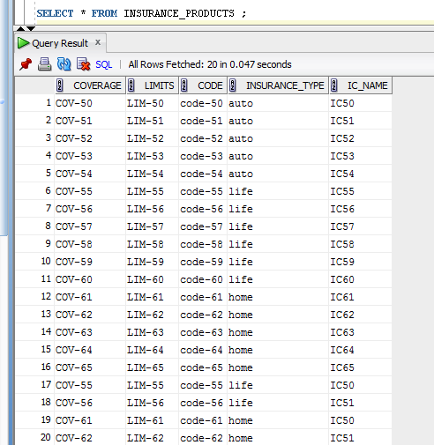

Insured_Person
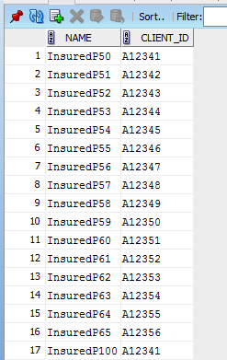

Offers_Com
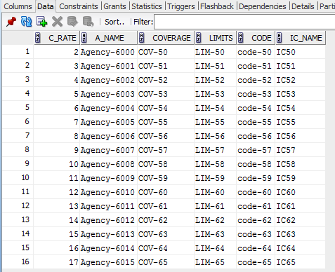
Offline_quote:
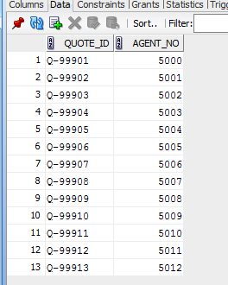

Online_quote:
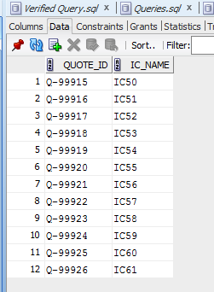

Payment
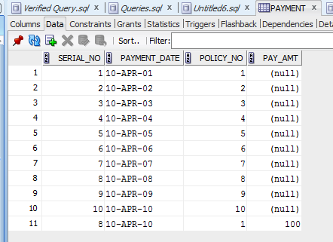

Policy:
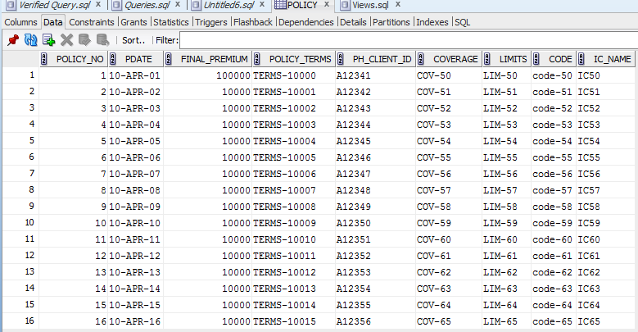

Policy_Holder

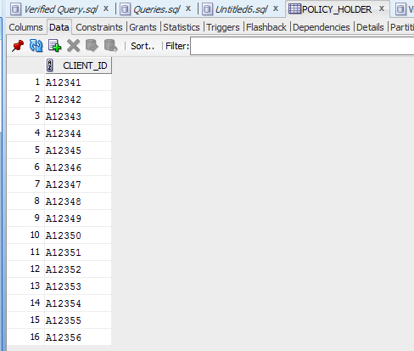
Quote:
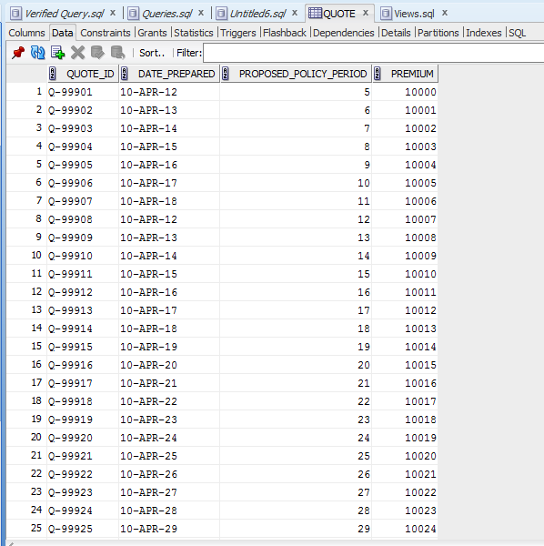

Refund

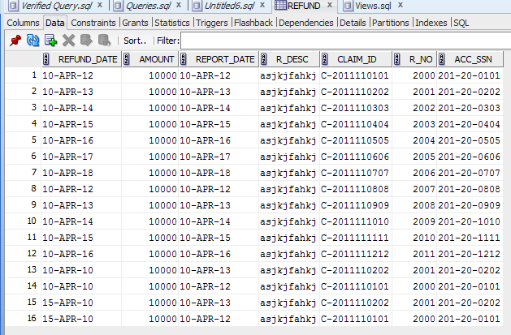

Refund_Related_to

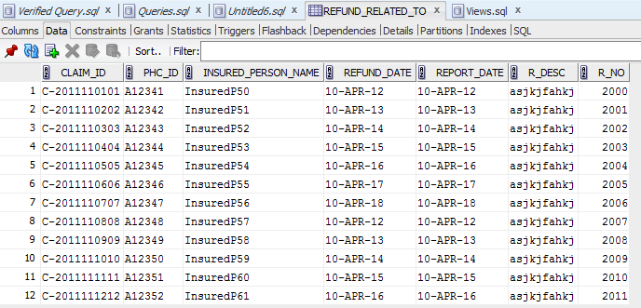

Report:

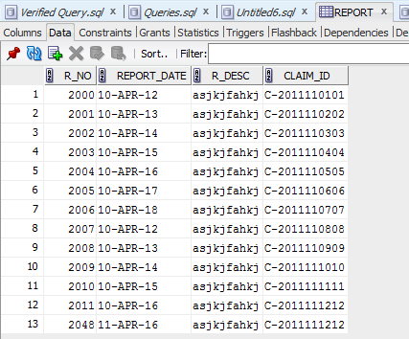
Sells:

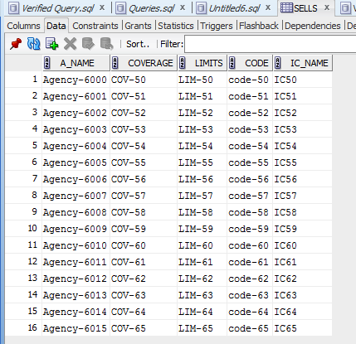

Store:

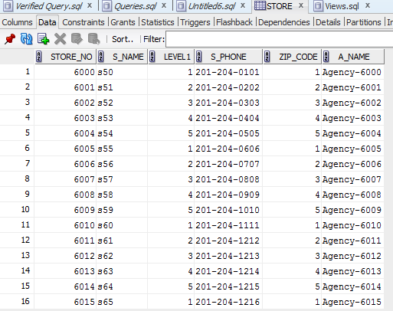

Store_mgr:

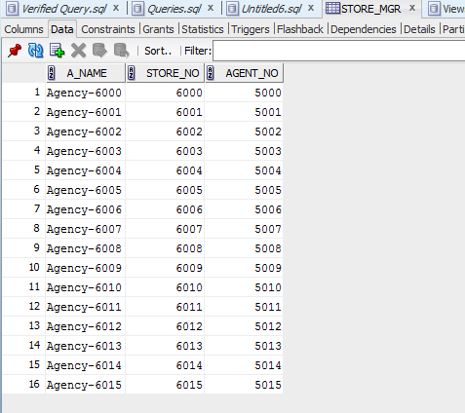

Store_zip:

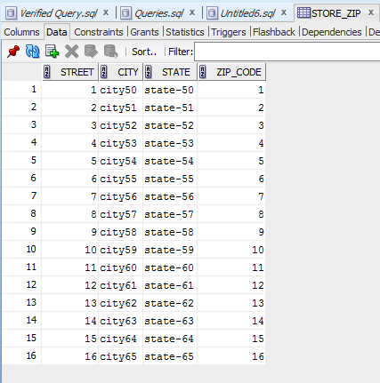

Works_For:

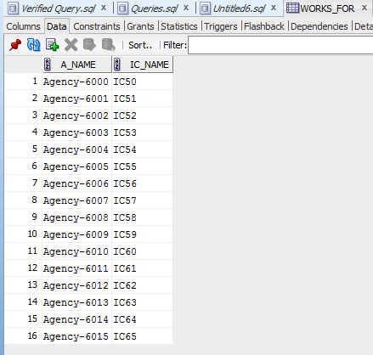

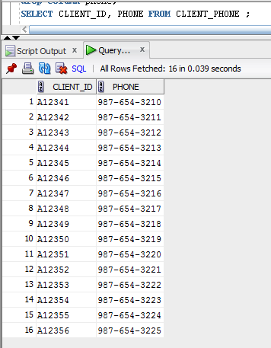

5.2 Creation of Views (Answer for Question d/Phase III)
--1. View1: This view returns all products related to any quotes in the system.
create or replace view View1 as
select ip.COVERAGE, ip.LIMITS, ip.code,ip.INSURANCE_TYPE,ip.IC_NAME
from insurance_products ip inner join sells s on
(ip.coverage=s.coverage and ip.limits=s.limits and ip.code=s.code and ip.ic_name=s.ic_name );
--------------------------------------------------------------------------------------------------------------View2: This view returns all stores associated with any policies with at least $500 final premium.

create or replace view View2 as
select .Store_no,c.S_name,c.Level1,c.S_phone,c.A_name,c.Street,c.City,c.State,c.Zip_code
from insurance_products m,WORKS_FOR n,
(select Store_no,S_name,Level1,S_phone,A_name,Street,City,State,b.Zip_code from Store a inner join Store_zip b on a.zip_code=b.zip_code) c,
policy p
where
m.ic_name=n.ic_name
and c.a_name=n.a_name
and p.coverage=m.coverage
and p.code=m.code
and p.limits=m.limits
and p.ic_name=m.ic_name
and p.final_premium>=500;
--------------------------------------------------------------------------------------------------------------View3: This view returns all policies that are related to any refunds issued in 2010.

create or replace view View3 as
select p.POLICY_NO,PDATE,FINAL_PREMIUM,POLICY_TERMS,p.PH_CLIENT_ID,
COVERAGE, LIMITS, CODE,IC_NAME
from refund r inner join claim c on c.claim_id=r.claim_id
inner join policy p on p.policy_no=c.policy_no
where
extract(year from refund_date)= 2010;
------------------------------------------------------------------------------------------------------------
--View4: This view returns all clients who issued any online quotes.
create or replace view View4 as
select c.CLIENT_ID,C_NAME,AGE,ADDR, cp.PHONE, EMAIL
from Client c inner join gets g on g.client_id=c.client_id
inner join quote q on q.quote_id=g.quote_id inner join client_phone cp on cp.client_id=c.client_id
where q.quote_id in ( select quote_id from online_quote)
;

5.3 Creation of SQL Queries (Answer for Question e/Phase III)
--1. Retrieve the IDs and names of all clients who live in Dallas.
Select Client_id,C_name from CLIENT where upper(Addr) like upper('%Dallas%');

--2. Retrieve the names and Tax IDs of all agencies who sell all types of products.

Select a.a_name,Tax_id, count(insurance_type)
From agency a, sells w, insurance_products p
Where a.a_name=w.a_name
And p.ic_name=w.ic_name
group by a.a_name,Tax_id
having count(insurance_type)=3;

--3. Retrieve the names and locations of all annual stores that earn the highest total premium on policy.
select rs.S_name,rs.Street,szip.City,szip.State,rs.Zip_code,TP
from
(
select S_name,M, max(totalpremium)as TP
from (
select p.ic_name,a.a_name,s.S_name,extract(year from Pdate) as M, sum(p.final_premium) totalpremium
from store s, policy p,WORKS_FOR wf, agency a
where p.ic_name=wf.ic_name
and wf.a_name=a.a_name
and s.a_name=a.a_name
group by p.ic_name,a.a_name,s.S_name,extract(year from Pdate)
) ss
group by ss.S_name,M
) temp, store rs, store_zip szip
where rs.zip_code=szip.zip_code
and temp.s_name=rs.s_name;

--4. Retrieve the names and the gross profits of all companies between 01/01/2010 and 12/31/2010. (Gross profit = all final premiums of policy – total amounts of refunds)

select IC_NAME,sum(FINAL_PREMIUM)-sum(r.amount) as GrossProfit
from refund r inner join claim c on c.claim_id=r.claim_id
inner join policy p on p.policy_no=c.policy_no
where
extract(year from refund_date)= 2010
group by ic_name;

--5. For each policy holder who has filed any claims, retrieve the name, address, phone number, insured person(s) who has the same name related in the claim.
select cl.c_name,cl.Addr,c2.phone
from client cl, client_phone c2
where cl.client_id=c2.client_id and
exists
(
select 1
from claim_related_persons c1 inner join claim_related_persons c2
on c1.insured_person_name=c2.insured_person_name
where c1.phc_id<>c2.phc_id
and cl.client_id=c1.phc_id
);
--6. Retrieve the distinct employees whose salary is greater than the salary of all the employees in the same company.

select distinct SSN from employee EP,
(select max(salary) as MaxSalary,ic_name from employee
group by ic_name) m
where EP.salary=m.MaxSalary
and ep.ic_name=m.ic_name;

--7. Retrieve the number of clients whose discount rate is bigger than 5%.

select count(client_id)
from discount d ,gets g,policy p
where
p.ph_client_id=g.client_id
and d.quote_id=g.quote_id
and rate>5;

--8. For each claims with total refund payments over $100000, retrieve the claim ID, the claim date, and the client name related to the claim.

select cl.claim_id,cl.claim_date,c.c_name
from claim cl,client c,
(select claim_id, sum(amount) as totalrefund
from refund
group by claim_id) m
where cl.claim_id=m.claim_id
and cl.ph_client_id=c.client_id
and totalrefund>100000;

--9. Retrieve the ID and names of all clients whose claim has more than three reports without any refunds.
select c.c_name
from client c,
claim cl, (select count(claim_id) reportsavlbl,claim_id from report group by(claim_id)) rep
where c.client_id=cl.ph_client_id
and rep.claim_id=cl.claim_id
and rep.reportsavlbl > 3
and not exists (select * from refund m where rep.claim_id=m.claim_id);

--10. Retrieve the names and phone numbers of all policy holders who have not fully paid for the policies held by them. (Hint: Final Premium > the sum of payments)

select cl.c_name,cp.phone
from policy p, client cl, client_phone cp,
(select Policy_no, sum(pay_amt) as totalPay
from payment
group by policy_no) m
where p.policy_no=m.policy_no
and p.final_premium>m.totalPay
and cl.client_id=p.ph_client_id
and cl.client_id=cp.client_id;

--11 For each policy, retrieve the policy ID, the policy name, the number of insured persons, and the total amount of payments.
select p.policy_no, p.policy_terms, m.totalpay,ip.totalIP
from
policy p ,
(select Policy_no, sum(pay_amt) as totalPay from payment pm group by policy_no) m,
(select count(*) as totalIP , client_id from insured_person group by client_id) ip
where p.policy_no=m.policy_no
and p.ph_client_id=ip.client_id;

--12. Retrieve the average age of all clients who only bought car insurance online.

select avg(distinct v4.age)as AVgAge
from view1 v1, view4 v4, policy p,gets g, online_quote q
where p.ph_client_id=v4.client_id
and p.coverage=v1.coverage
and p.code=v1.code
and p.limits=v1.limits
and p.ic_name=v1.ic_name
and v4.client_id=g.client_id
and g.quote_id=q.quote_id
and v1.insurance_type='auto'
and not exists
(select * from view1 v1, view4 v4, policy p,gets g, online_quote q
where p.ph_client_id=v4.client_id and p.coverage=v1.coverage and p.code=v1.code and p.limits=v1.limits and p.ic_name=v1.ic_name and v4.client_id=g.client_id and g.quote_id=q.quote_id
and v1.insurance_type not in ('home','life'));

--13. Retrieve the names, the salaries and social security numbers of distinct employees who works as an adjuster and also an accountant of a same claim for ABC insurance company.
select emp.ssn,emp.salary,emp.fname,emp.minit,emp.lname
from Evaluates e, refund r, employee emp
where e.adj_ssn=r.acc_ssn
and adj_ssn=emp.ssn
and emp.ic_name='IC50';

--14. For each insurance company, retrieve the code of product with the highest commission rate and the tax IDs of all agencies that has the product.
select c.ic_name,c.code,c.Tax_id,max(c.c_rate)
from (select oc.ic_name,oc.code,oc.c_rate,a.tax_id
from offers_com oc, agency a
where a.a_name=oc.a_name) c
group by c.ic_name,c.code,c.Tax_id;

--15. Retrieve the name of the earliest agency that has more than 5 stores in Houston and sells more than 10 products.
select a.a_name,max(yrs_in_biz)
from agency_taxid at, agency a
where a.tax_id=at.tax_id
and a.a_name in
(
select ags.a_name
from store ags,store_zip szip
where ags.zip_code=szip.zip_code
and szip.city='Houston'
and ags.a_name in
(select ag.a_name
from sells s, agency ag
where ag.a_name=s.a_name
group by ag.a_name
having count(ag.a_name)>10)
group by ags.a_name
Having count(store_no)>5
)
group by a.a_name;

6. Dependency Diagram
We now draw a dependency diagram for each table from Figure 2 as follows:
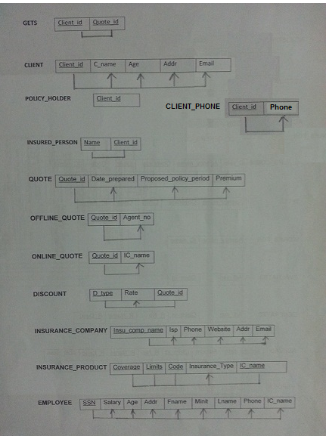

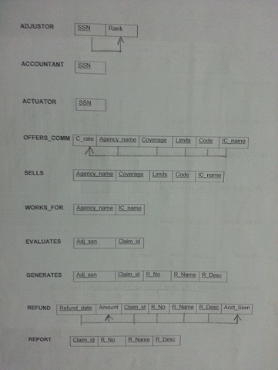

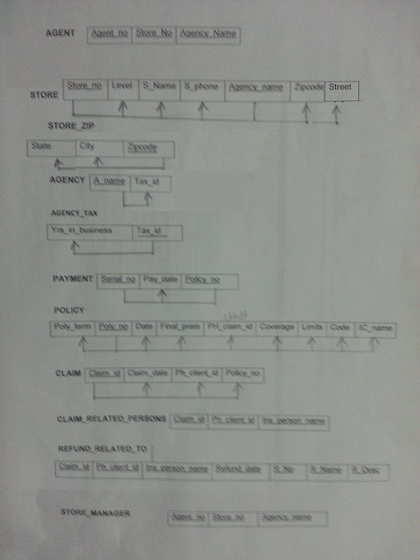

7. Conclusion
In this final report we summarized all the necessary descriptions and solutions for Insurance management system database, including process and result of EER diagrams, relational schemas in third normal form, SQL statements to create database, create view and solve corresponding queries, as well as dependency diagram. We also implement the whole database in Oracle and using a database state to test every query. In section 2 we also explained why we use superclass/subclass relationship to build relational schema, why we choose a Relational DBMS to implement our database, and the additional five business rules shown from implementation.

